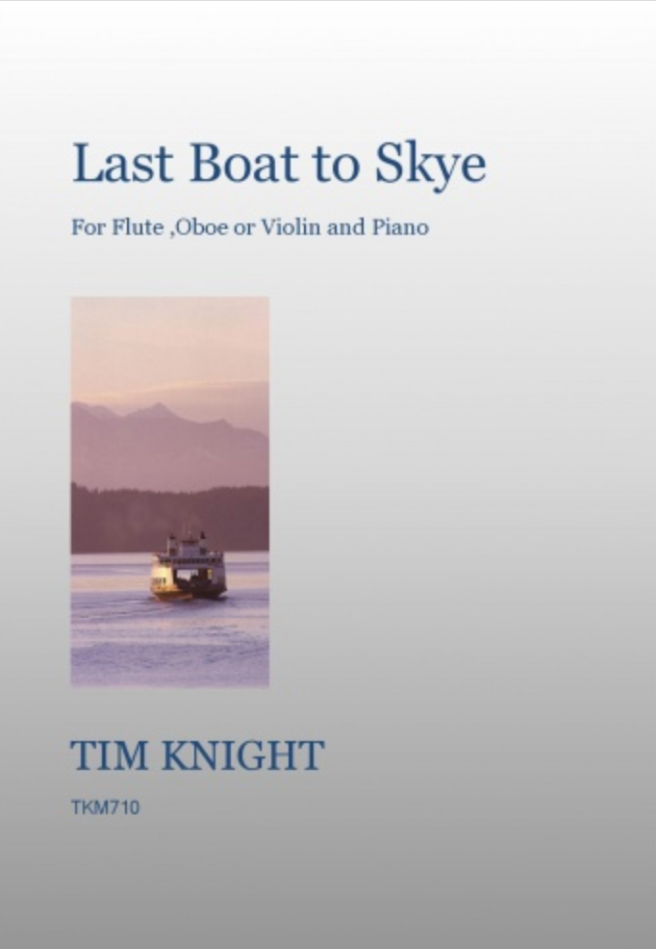
INSTRUMENTAL & ORCHESTRAL MUSIC

A wide range of pieces, all composed by Tim Knight and covering all performance levels for woodwind, strings, piano, trumpet, mixed ensembles, string quartet, string orchestra, small and full orchestra
RECENT RELEASES
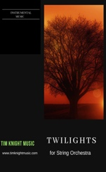
Twilights – for String Orchestra
TKOP05 – Printed and bound - £12.00
TKODL05 – PDF Download - £9.00
“Twilights” is a short descriptive piece for String Orchestra which is useful for beginner orchestras or as a concert filler.

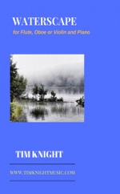
Waterscape - for Flute, Oboe or Violin and Piano
TKM828 - Printed and bound - £8.95
Adding to our “Scape’ series and joining the ever-popular ‘Winterscape’ comes another melodic and lyrical piece suitable for Flute, Oboe or Violin with piano accompaniment.

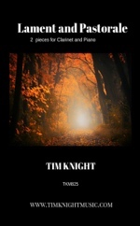
Lament and Pastorale – for Clarinet and Piano
TKM825 – Printed and bound - £8.25
These two atmospheric pieces were written for Clarinettist, Dan Gibson, and are ideal for teaching or concert use.
BEST SELLERS

Winterscape – for Flute and Piano
TKM812 – Printed and bound - £8.95
A single-movement hauntingly beautiful flute and piano piece which was premiered in 2017 in a series of lunchtime Cathedral recitals and was very well received. This piece is an enduring best-seller and can also be played on the Oboe or Violin with piano accompaniment.

Elegy for an English Summer – for Chamber Orchestra
TKM617 – Full Score and parts - £17.95
This piece won a Masterworks Prize and was subsequently recorded by the Czech Philharmonic on the “ERM Masterworks of a New Era Volume 2” CD. It is for small Orchestra and has been nominated in the ClassicFM’s Hall of Fame for the last 5 consecutive years!

Last Boat to Skye – for Flute, Violin or Oboe and Piano
TKM710 – Printed and bound - £5.95
Originally conceived for Guitar and Piano, this piece is both lyrical and melodic with a definite Scotch flavour! It is a popular recital piece and can be played on the Flute, Violin or Oboe with piano accompaniment. There are lots of recordings on Youtube.
www.timknightmusic.com

Music Publishers of Accessible, Affordable and Appealing Music
in Yorkshire since 1999
East Coast Suite – for Woodwind Quartet
FM691 – Printed and bound - £12.00
This popular Woodwind Quartet recently received an honourable mention in the NFA's newly published music competition in the mixed ensembles category. Inspired by a retreat to a cottage on the East Coast - Comprises 3 movements – Whitby Harbour, Saltburn Sands and Sandsend.

Summer Suite
WOODWIND MUSIC FOR BEGINNER ENSEMBLES
MUSIC FOR FLUTE / FLUTE ENSEMBLE
TKM601 – Printed and bound - £7.25
“This suite is in 3 movements and is delightful. It will suit players from about Grade 5 (ABRSM) standard. The piano part is very approachable for the immediate standard player.” … Flutewise

Nordic Suite
TKM604 – Printed and bound - £8.95
For 2 flutes and piano in three movements. Performance level 6. “There is something refreshing about this suite, as it isn’t exactly what you might expect for this combination. Full of Scandinavian colour, it immediately transports you to the snow-covered landscape of the cover!......” ... Just for Flutes

Solitude
TKM616 – Printed and bound - £2.95
A short recital piece with a completely independent flowing piano line.

Lakeland Suite
TKM706 – Printed and bound - £6.95
A companion to the very popular “Summer Suite”, here is a 3-movement suite which is lyrical and in places melancholy.

Steel City Shuffle
FM655 – Printed and bound - £12.00
A lively and energetic piece written for a Sheffield Flute Choir and inspired by the composer’s love of railways! Available from www.timknightmusic.com or directly from the UK Publishers www.fortonmusic.co.uk.

Moorland Suite
FM787 – Printed and bound - £8.00
These pieces were commissioned for use as Guitar and Flute Duos; in that form the guitarist is free to play the chords in whatever style they choose. A piano part is also provided so that these pieces might also be used as flute/piano concert pieces. There are two separate movements (Moorland Stroll and Through the Heather), though they do share some material which would make them suitable for playing as a pair. Available from www.timknightmusic.com or directly from the UK Publishers www.fortonmusic.co.uk.

Allegro for Four Flutes
PP124 – Printed and bound - £4.95
Suitable for beginner ensembles. Includes score and parts. Available from www.timknightmusic.com or directly from the UK Publishers www.phylloscopus.co.uk.

The Hedgehog
PP166 – Printed and bound - £4.95
For 4 flutes and suitable for beginner ensembles. Includes score and parts. Available from www.timknightmusic.com or directly from the UK Publishers www.phylloscopus.co.uk.
MUSIC FOR MIXED INSTRUMENTS
Three Pieces for Woodwind
PP332 – Printed and bound - £6.95
For either Flute, Clarinet or Oboe with piano. Comprises 3 pieces: 2 Celtic Tunes and Alegretto Pastorale with parts supplied for Bb and C Instruments. One of the Celtic Tunes has an appealing Youtube recording on our Channel Available from www.timknightmusic.com or directly from the UK Publishers www.phylloscopus.co.uk.

These pieces are all suitable for beginner woodwind ensembles. They include score and parts and are available from www.timknightmusic.com or directly from the UK Publishers www.phylloscopus.co.uk.

Frogs March
PP137 – Printed and bound - £4.95
For Flute, Oboe, Clarinet in Bb and Bassoon

Short Woodwind Suite
PP148 – Printed and bound - £4.95
For Flute, Oboe, Clarinet in Bb and Bassoon

Dialogue and Two Marches
PP202 – Printed and bound - £7.95
For Flute, Oboe, Clarinet in Bb and Bassoon

3 Miniatures and an Andante
PP203 – Printed and bound - £4.95
For 2 Oboes and Cor Anglais
MUSIC FOR CLARINET
Highlands and Islands Suite
TKM602 – Printed and bound - £5.95
The 3 movements of this evocative piece add up to about 6 minutes and include a quasi Scottish dance! There is a beautiful live recording from the wonderful chapel of Millport Cathedral on the Isle of Cumbrae. Performance level 8,6.

Beside Still Waters
TKM603 – Printed and bound - £7.95
The various stanzas of Psalm 23 are set here in these reflections which are designed to play in a set or in worship services for music groups. Flexible scoring suitable for any ‘C’ Instrument. Performance level 4,6.

Winters Rhapsody II
PP173 – Printed and bound - £9.95
Arrangement for solo Bb Clarinet and String Orchestra. “Just in time to save ‘rhapsody’ from going out of fashion as a musical description, Tim Knight’s 1-movement work (for that is the essence of such a name) has all the right ingredients. ……” … Music Teacher Magazine. Available from www.timknightmusic.com or directly from the UK Publishers www.phylloscopus.co.uk.

Nordic Sketches
TKOP04 – Printed and bound - £19.95
TKODL09 – PDF Download - £9.00
A three-movement suite for Clarinet and String Quartet/Orchestra. These pieces in total last about 10 minutes and are very melodic and descriptive. Comes beautifully bound with a striking cover. Only available from www.timknightmusic.com.
Devil’s Dance – Emerson Edition
MUSIC FOR OBOE
E356 – Printed and bound - £6.75
For many years this quirky Oboe and Piano piece was on the Grade 6 Trinity exam syllabus, a little different! Available from www.timknightmusic.com or directly from the Publishers www.juneemersonwindmusic.com.
Dales Suite
MUSIC FOR STRING QUARTET / STRING ORCHESTRA
MUSIC FOR OBOE CONTINUED
TKM701 – Printed and bound - £7.95
This suite of 3 pieces, ranging from expressive and lyrical to fast and furious, are ideal for concert use and also for teaching material. The Dales Suite refers to the Yorkshire Dales and the cover picture is Penyghent, one of the three peaks.

Spring Wander
PP333 – Printed and bound - £3.95
A gentle and lyrical concert piece about 4 minutes long which was first performed at the Yorkshire Composer’s Festival. Includes score and parts. Available from www.timknightmusic.com or directly from the UK Publishers www.phylloscopus.co.uk.
MUSIC FOR PIANO

These are a set of 3 very popular pieces which are ideal for concerts or teaching purposes:

3 Celtic Reflections
TKM400 – Printed and bound - £3.95

3 Icelandic Sketches
TKM401 – Printed and bound - £3.95

3 English Portraits
TKM700 – Printed and bound - £3.95
MUSIC FOR ORCHESTRA
MUSIC FOR TRUMPET
Trumpet Concertino (Tim Knight)
WM340 – Printed and bound - £7.95
Performed by the Cooman brothers, this is a 3-movement piece written for the 1996 Saarlouiser Organ Day and consists of "...three accessible, effective and succinct movements...and if you are interested in this repertoire, you should seriously consider getting the score..." - John Humphries. Also highly recommended by the International Trumpet Guild. Available from www.timknightmusic.com or directly from USA Publishers www.wehrs-music-house.com.

Moorland March (Tim Knight)
TKM814 – Printed and bound - £7.95
A lively 3-minute concert piece for BbTrumpet and Organ or Piano. “Both the organ and trumpet parts are clearly produced and well laid out. They are reasonably priced and will make a useful addition to the trumpet/organ repertoire..." … The Conductor
MUSIC FOR VIOLIN
Rossenby Suite
TKM622 – Printed and bound - £7.25
A suite of 3 pieces – one very Celtic, one very relaxed and one very fast and furious!
HOW TO ORDER

Our music is available to buy either from us at www.timknightmusic.com, directly from the individual publishers listed and in all good music shops and online retailers. Please contact us at mail@timknightmusic.com with any queries. Prices shown do not include postage & packing.

These pieces include the full score - parts can be supplied free on a CD by email request to mail@timknightmusic.com.

Voyage of Hope
TKM610 – Printed and bound - £7.95
A lush, English-Sounding Elgarian piece for double string orchestra.

Miramichi Dawn
TKM612 – Printed and bound - £5.95
Inspired by a fishing trip down the Miramichi River! For String Orchestra.

Winter Lakes
TKM614 – Printed and bound - £4.55
A String Orchestra setting of the song of the same name.

Alpine Reverie
TKOP03 – Printed and bound - £14.95
Inspired by a choir trip to beautiful Bregenz in Austria and Lichtenstein. Written for String Quartet or String Orchestra and comes with a set of parts. Only available from www.timknightmusic.com.

Morning and Evening
CMP602 – Printed and bound - £3.00
Two short string quartets with Violin 3 as an alternative to Viola, these were my first ever published pieces and are an excellent introduction to string ensemble playing. Available from www.timknightmusic.com or direct from the Publishers, www.cordamusic.co.uk.
These pieces include the full score - parts can be supplied free on a CD by email request to mail@timknightmusic.com.

Artengill
TKM606 – Printed and bound - £19.50
A day in the Yorkshire Dales – movements seamlessly join through a series of moods. Was the chosen piece to open a concert hall in Leiden, Holland.

Northern Lights
TKM607 – Printed and bound - £19.50
One of the most fascinating spectacles in the world, and something that shows the power of nature, this tone poem for Orchestra seeks to conjure up the mystery majesty and marvel of the Northern Lights.

Portrait of a Capital
TKM608 – Printed and bound - £19.50
Fanfares and an Eastern European big tune for this portrait of Warsaw written for Orchestra.

Tints of Autumn
TKM609 – Printed and bound - £9.95
A short piece for Small Orchestra and Piano reflecting the changing colours of Autumn.

